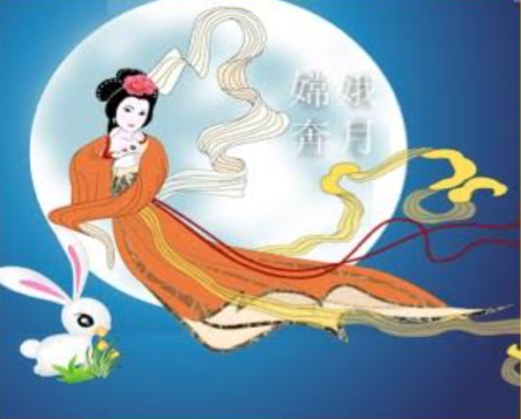
慶 祝 中 秋 節 晚 宴
Celebration of Chinese Moon Festival
Sunday, Sept 23, 2018 6:30pm to 9:00pm
Shangri La Chinese Restaurant
8850 N. Union Blvd. Colorado Springs, CO 80920

Menu
Choices of soup: Egg drop, Won ton or Hot and Sour蛋花湯，餛飩湯或酸辣湯
Salt Pepper Prawns鹽胡椒蝦
Roast Duck香酥鴨
Mongolian Beef蒙古牛
Green bean and Pork with Black bean sauce四季豆炒肉絲
Green tea ice cream綠茶冰淇淋

Cost: $29.00 for non-members. $27.00 for CSCCI Members
Please reserve your seats by sending a check payable to CSCCI or register online. Payment must be received by Sep. 18, 2018
CSCCI P.O. Box 2625 Colorado Springs, CO 80901
For more information of CSCCI, check the website at www.cscci.org
(719)287-7624

